

Monterrey Campus

Autonomy of Unmanned Aerial Vehicles
MR3003C.601

Report:
Practice 06 – Motor position Control
Part A. PV Control Strategy

Name:
Carlos Hernán Auquilla Larriva | A00834778

Teachers:
Carlos Gustavo Sotelo Molina, Ph.D
David Alejandro Sotelo Molina, Ph.D

Due date:
September 2nd, 2024
Table of contents
1. Mathematical Expression for the Control Law u(t) 3
2. System Response with the PV Controller with predefined Gain Values 3
3. Qualitative Analysis of the Controller 3
4. Mathematical procedures. 5
a. Closed-Loop Transfer Function 5
b. Expressions for Kp and Kv in terms of the System Parameters 6
5. Matlab Script to compute Controller Gains 7
6. System Response with the PV Controller with obtained Gain values 8
7. Tunning Procedure of the Control Gains 10
8. PD Controller Analysis 12
9. Simulink Model for Servocontrol with reference to a Second QUBE-Servo 3 14
10. Conclusions 14

Mathematical Expression for the Control Law u(t)
$$U\left(s\right)=K_{p}*E\left(s\right)-K_{v}*θ_{m}\left(s\right)*s$$
$$u\left(t\right)=K_{p}*e(t)-K_{v}*ω_{m}\left(t\right)$$

System Response with the PV Controller with predefined Gain Values
Kp = 2.5 [V/rad]; Kv=0.05[V-s/rad]
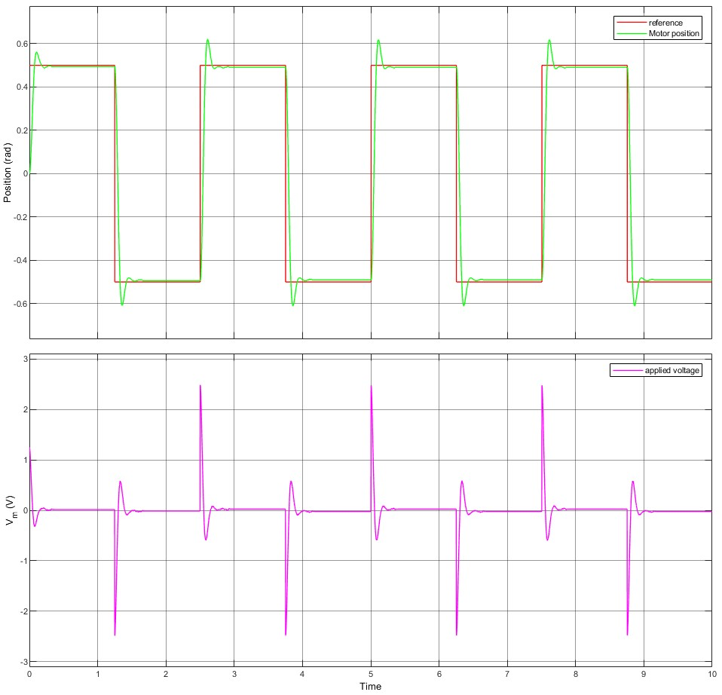

Qualitative Analysis of the Controller
As you can see in the following table, different transient responses of the system were obtained. It is worth noting that, as the Kp value increases, so does the overshoot; however, as expected, the peak time decreases. As the value of Kv increases, the overshoot of the system response is directly modified as it decreases.
Kp[V/rad] | Kv[V-s/rad] | System Response
1 | 0 | 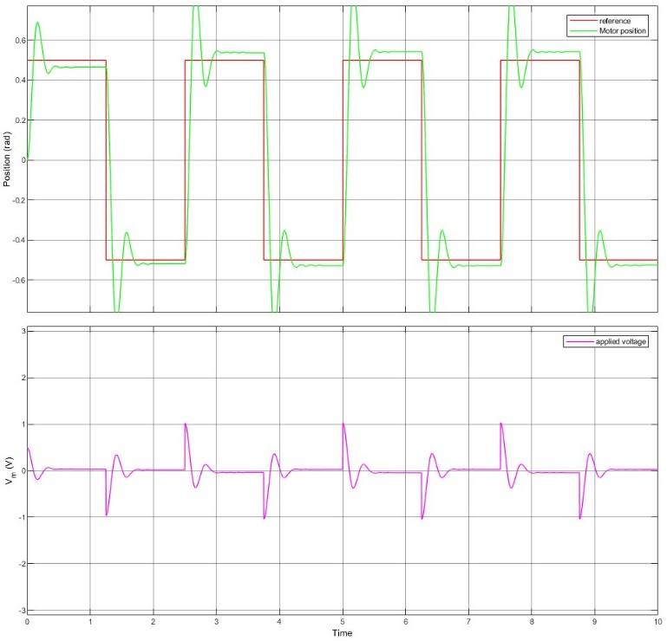
4 | 0 | 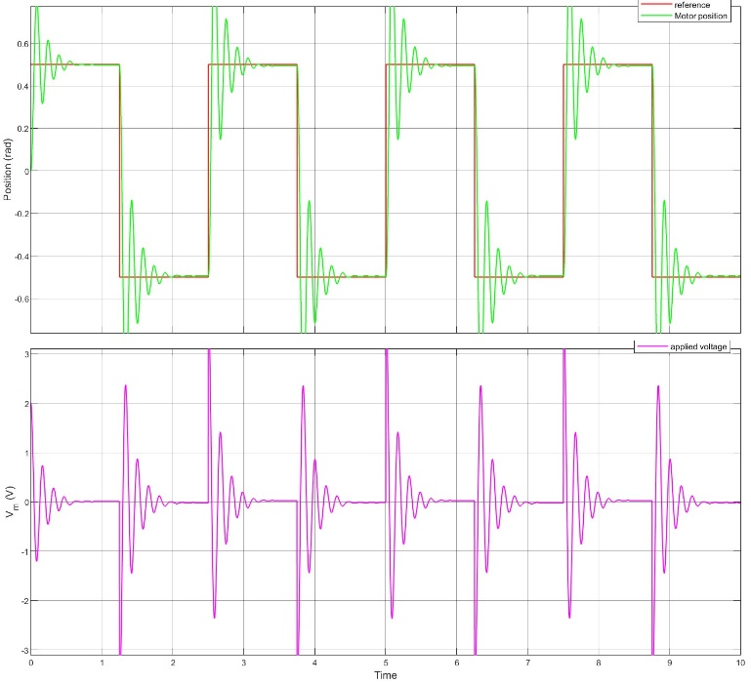
2.5 | 0 | 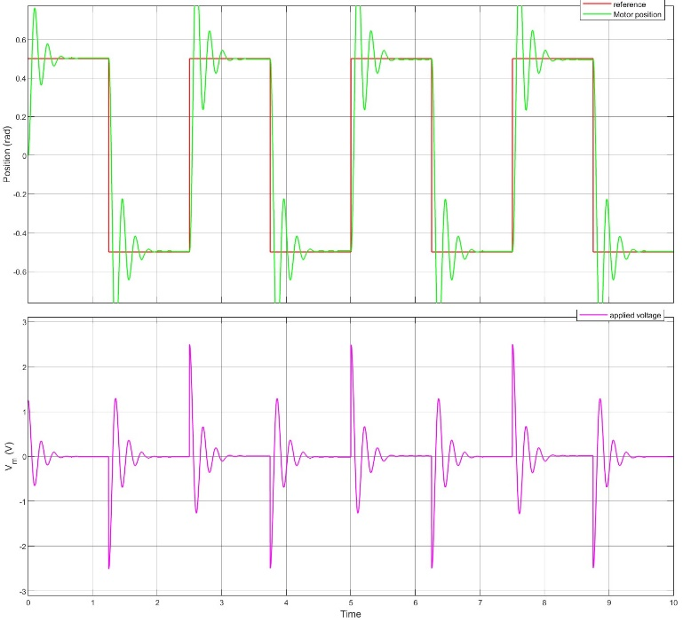
2.5 | 0.15 | 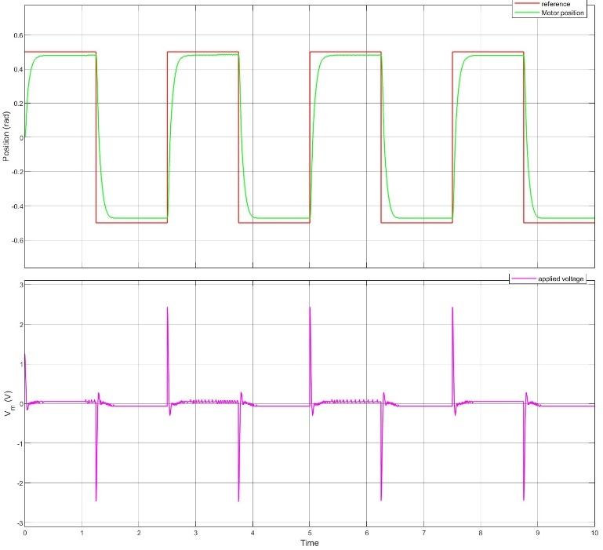

Mathematical procedures.

Closed-Loop Transfer Function

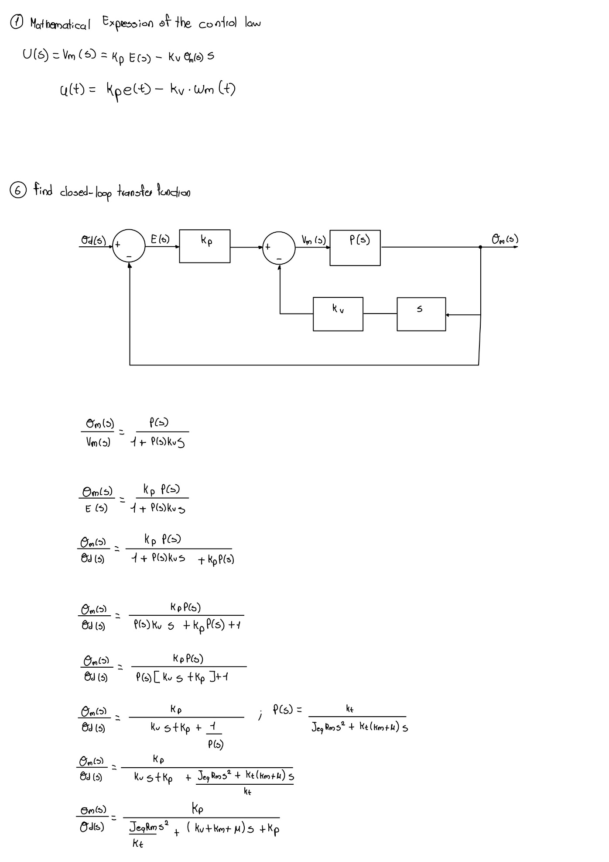

Expressions for Kp and Kv in terms of the System Parameters
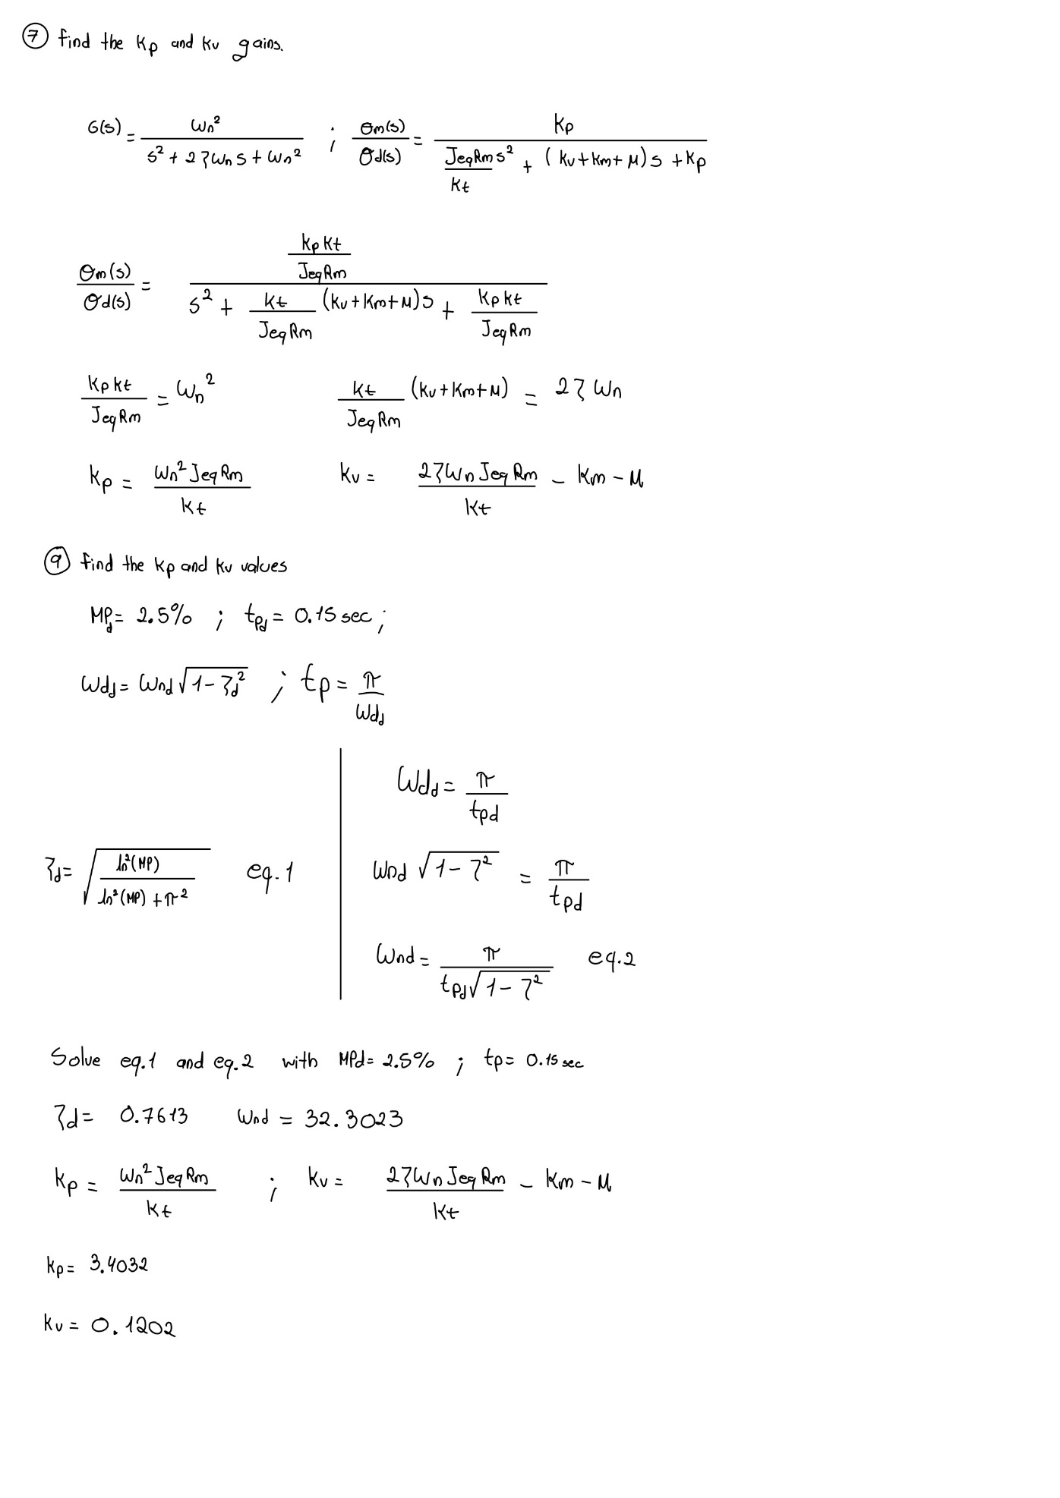

Matlab Script to compute Controller Gains

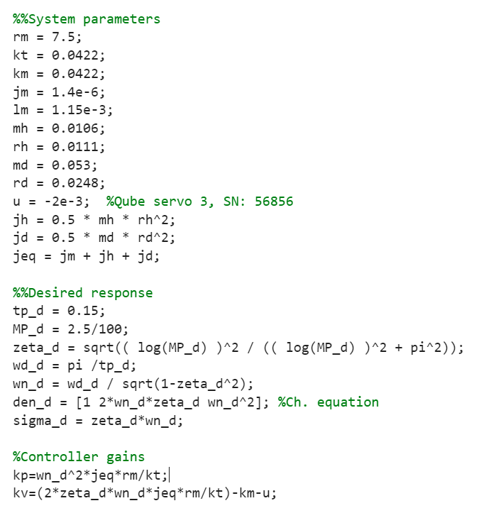

System Response with the PV Controller with obtained Gain values
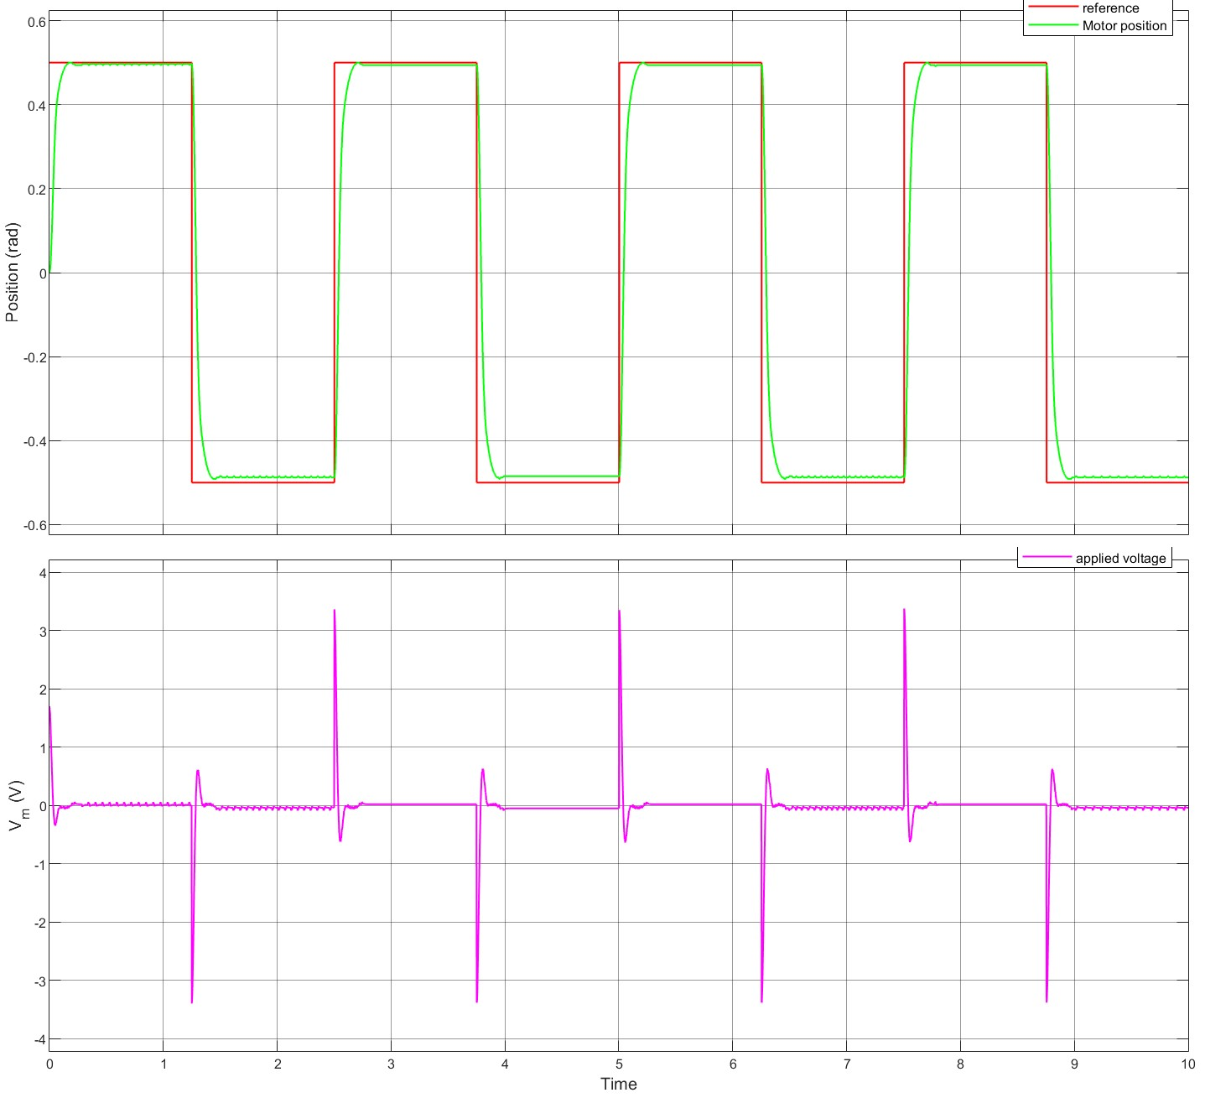
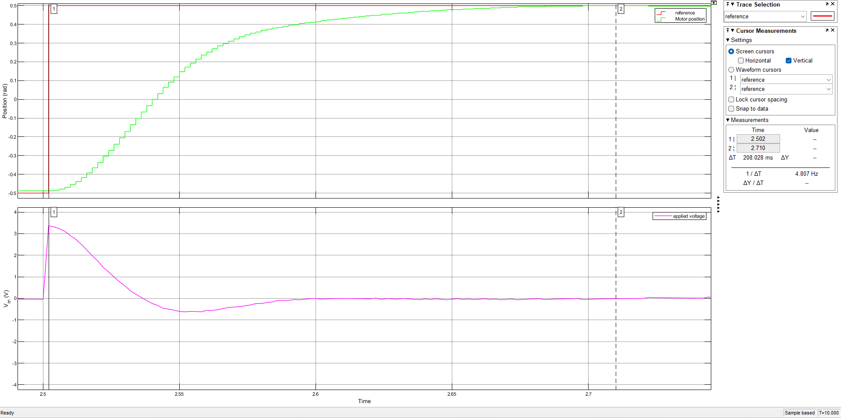
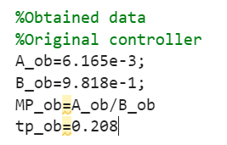
$$\%{MP}_{ob}=0.63\%$$
$$t_{p_{ob}}=0.208\left[sec\right]$$
As we can see in the previous figures, the controller significantly improves the overshoot value; however, the required peak time is not satisfied. Due to the assumptions made previously in the mathematical model, where a term inside the differential equation was cancelled out and there were some practical variations on the system parameters, the system response has varied with respect to the expected results.

Tunning Procedure of the Control Gains
The tuning procedure used in this step was trial and error. With the previously obtained gain values for the controller, we can start varying one at a time. In this case, the value of Kp was varied to meet the performance indexes. 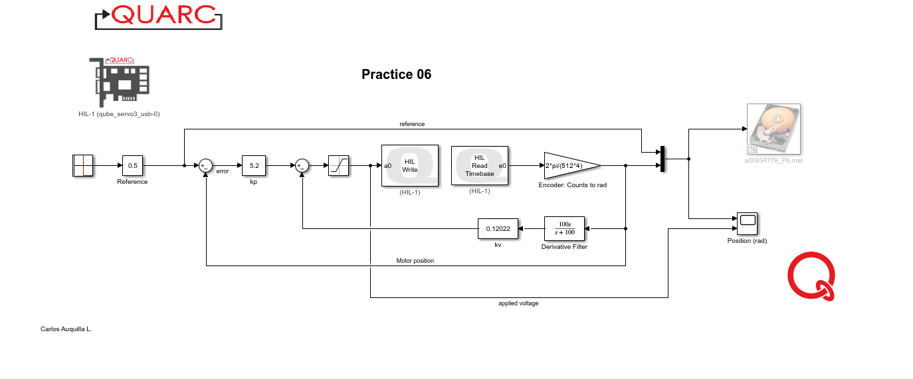
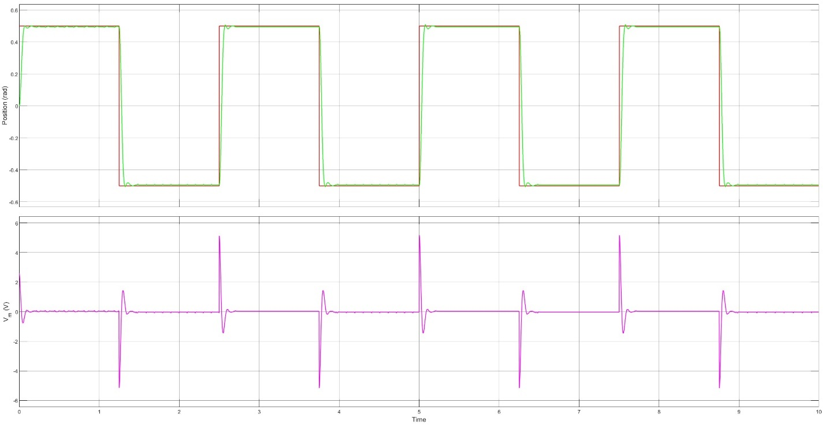
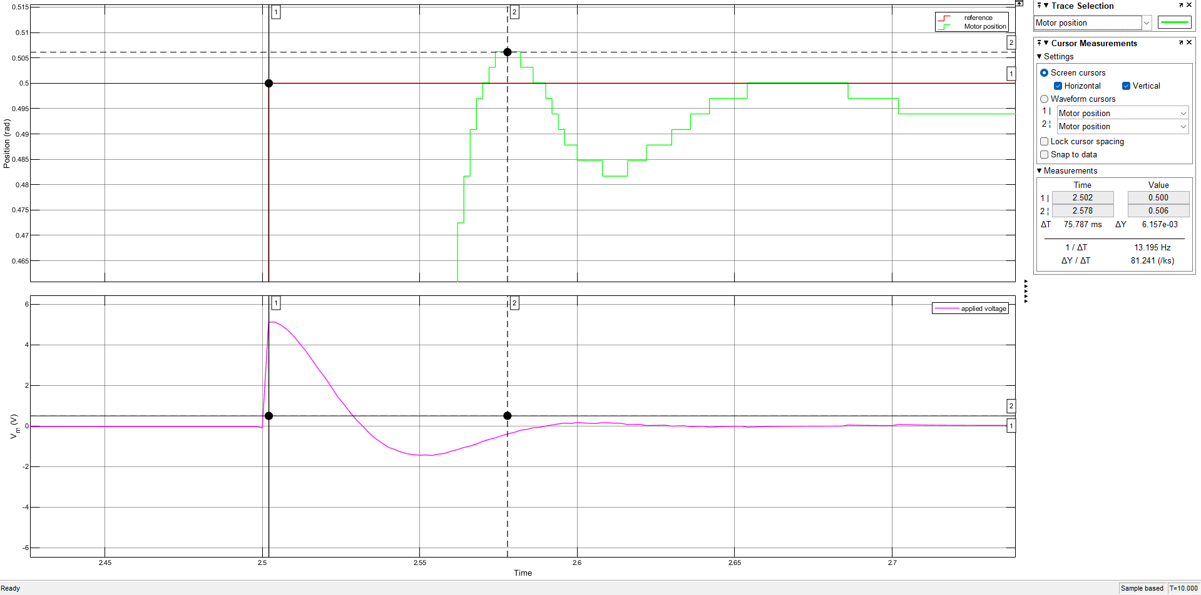

$$\%{MP}_{mod}=0.62\%$$
$$t_{p_{mod}}=0.0758\left[sec\right]$$

PD Controller Analysis
The main reason why the PV controller is used instead of a PD controller is because of the setpoint kick phenomenon, where the manipulated variable achieves great values, resulting in reducing the time of life of the actuators.
As we can see in the following figure, the manipulated variable in this case the voltage of the motor achieves its maximum values of operation.
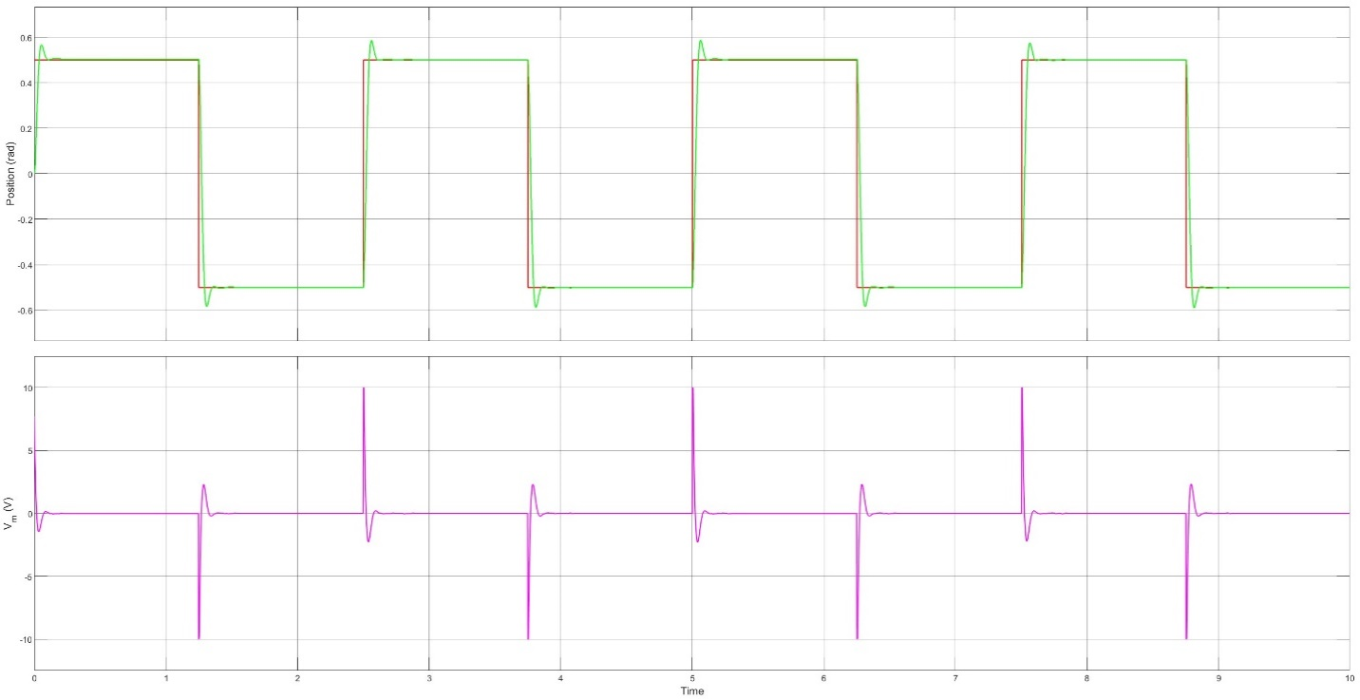

If the system would not be saturated between a specific range of values, the manipulation values would be as the following figure:
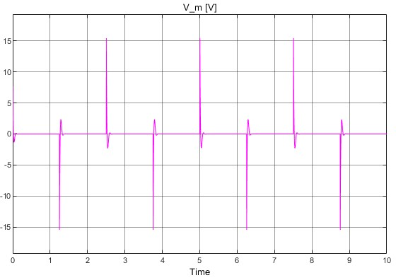

Simulink Model for Servocontrol with reference to a Second QUBE-Servo 3
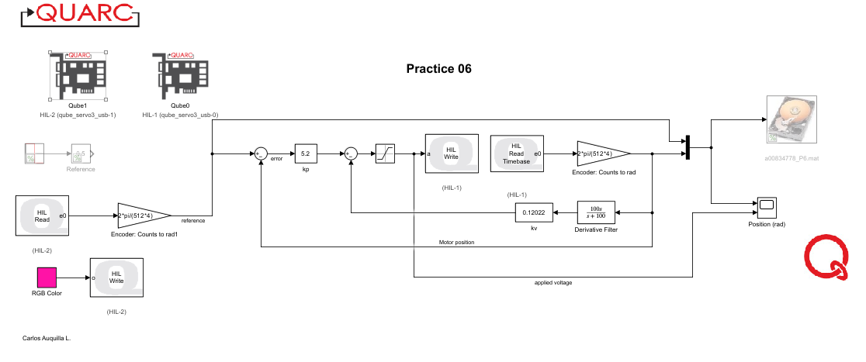
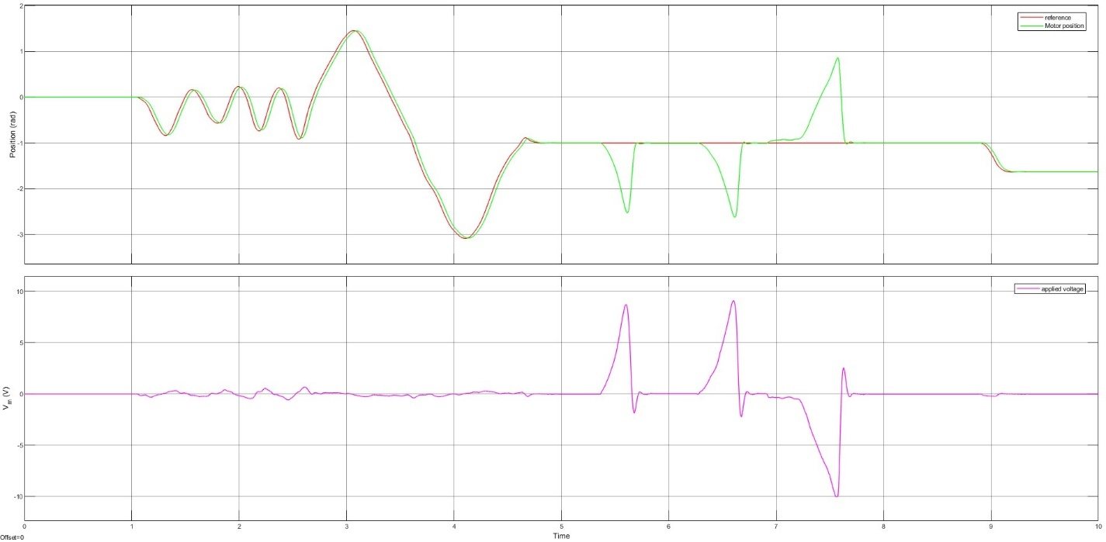

Conclusions
In this practice, the Proportional-Velocity (PV) control strategy was effectively applied to motor position control. Key outcomes include:

1. Performance Improvement: The PV controller with tuned gains demonstrated reduced overshoot and improved system stability compared to the predefined values, though the peak time did not meet the initial expectations.
2. Tuning Insights: Adjusting Kp and Kv proved crucial, with higher Kv reducing overshoot and varying Kp affecting peak time. The trial-and-error tuning process improved performance metrics.
3. Comparison with PD Controllers: The PV controller avoided issues like setpoint kick phenomenon that are common with PD controllers, making it more suitable for this application.
Overall, the PV controller effectively managed motor position with room for further optimization through precise tuning.

